NBA PLAYER ANALYSIS

The NBA Player Analysis Dashboard Report provides a detailed examination of player performance metrics and physical attributes across multiple NBA seasons. This report delves into the data visualized in the dashboard, offering insights into how factors such as sprint speed, wingspan, weight, and agility contribute to player success and draft selection. Through this analysis, we aim to uncover trends, highlight standout performers, and present a clear picture of the physical and performance-related characteristics that have shaped the careers of NBA players over the years.

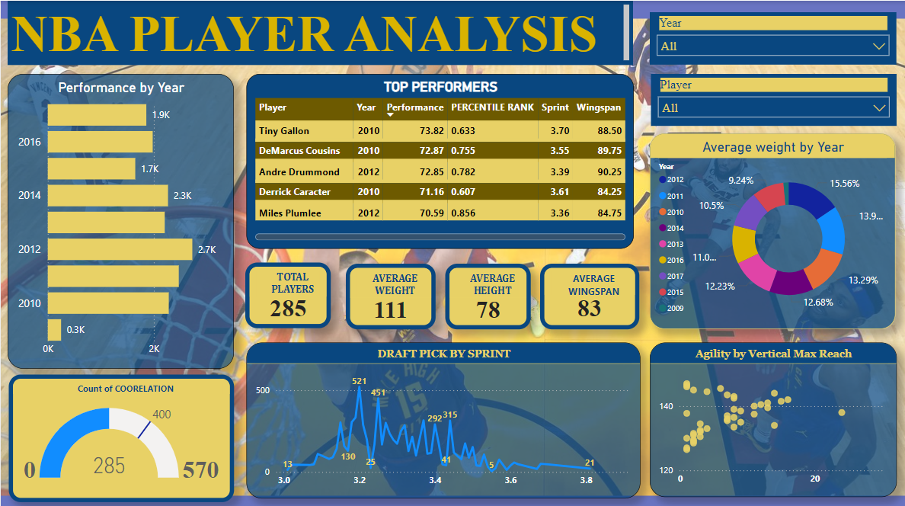

**OVERALL PLAYER STATISTICS:**

* TOTAL PLAYERS: 285
* AVERAGE WEIGHT :111
* AVERAGE HEIGHT: 78
* AVERAGE WINGSPAN: 83

ANALYSIS :

* Average height has been decreasing over the years.
* The average weight of players over the years is relatively stable, with 2012 having the highest percentage of players (15.56%) and 2015 showing the lowest (9.24%).
* Performance peaked in the mid years and then became consistent.
* The dashboard notes a total of 285 players analyzed, with a count of correlations reaching 570. This indicates multiple instances of performance metrics being correlated with other variables such as sprint speed, weight, and agility.

TOP PERFORMERS ACCORDING TO THEIR PERFORMANCE MATRIX:

* Tiny Gallon (2010)

Performance Matrix:73.82

* DeMarcus Cousins(2010)

Performance Matrix:72.87

* Andre Drummond(2012)

Performance Matrix:72.85

* Derrick Caracter(2010)

Performance Matrix:71.16

* Miles Plumlee(2012)

Performance Matrix:70.59

DRAFT PICK BY SPRINT OF PLAYERS:

The line chart shows the draft pick by sprint of the players. The most frequent sprint times range between 3.2 and 3.8 seconds, with the peak draft pick number reaching 521. This indicates that speed is a significant factor in draft selection, with players showing quicker sprint times being more favourably considered. High draft picks often have the versatility to play multiple positions, which can be particularly beneficial in a fast-paced style of play like a sprinting offense. This versatility allows a team to adapt quickly during games and exploit mismatches.

PERFORMANCE BY YEAR:

The chart on the left displays player performance by year, with a notable spike in 2012, reaching approximately 2.6k in performance metrics. In contrast, 2009 shows the lowest performance at around 0.3k, indicating that this year had less impactful player contributions compared to later years.

KEY INSIGHTS:

1. **2012 as a Standout Year**: Performance peaked in 2012, making it a pivotal year in the dataset.
2. **Importance of Sprint Speed**: Sprint speed is a critical factor in draft decisions, as evidenced by the high draft picks correlated with faster times.
3. **Consistent Physical Metrics**: Player weight and height have remained consistent, with only slight variations over the years.
4. **Agility and Vertical Reach**: Players who excel in vertical reach also tend to have higher agility scores, which is important for their overall performance.

This analysis provides valuable insights into the factors influencing NBA player performance and draft selection, emphasizing the importance of physical attributes and sprint speed in the evaluation process.